Sharpening for Landscapes

November 5th 2020

In this meeting we had a look at various techniques for sharpening applicable to Landscapes and Chris shared his methodology.

Chris’s Disclaimer. This document contains information believed to be correct at the time of writing, by the author. The methodology may change in time depending on improved knowledge. If you think anything in this paper is wrong then please say so, so that all can learn from the experience. There may be a variety of methods for reaching the same point, which suits others.

Sharpening in General
Sharpening is a process applied to images to improve the appearance by making identifiable lines and edges to objects crisper. ( Keeping it simple!)

The traditional way in the past was to use a filter called the Unsharp mask which was originally introduced to correct the image coming from a Digital Camera which has an anti-aliasing filter. The camera compensates for the filter so that is not visible in the image and the unsharp mask ‘cures’ and restores the intended image. Unfortunately applied Globally across the image it is a blunt instrument which does not recognise edges and can equally sharpen noise.

In programmes like Photoshop this can be applied in selected areas to avoid global sharpening but that latter problem remains.

In Photoshop Smart Sharpen is much better since it does detect edges and enhances them and can be applied selectively.

More on sharpening:

https://helpx.adobe.com/uk/photoshop/using/adjusting-image-sharpness-blur.html

In Lightroom, Sharpening can be applied Globally and indeed the “Out of the Box” setting applies 40% sharpening to the whole image as a default! Although Global Sharpening does have a mask which allows edge detection and a radius which allows pixel width of sharpening to the set.

Unfortunately this applies sharpening to clouds as well as landscape detail, which is NOT wanted. A better way of sharpening in Lightroom is to turn OFF the Global Sharpening and re-apply it where you want it using the adjustment brushes.

Some additional sharpening can always be added in Lightroom locally as required.

Sharpening with the High Pass Filter

This is a more subtle way of applying sharpening to a landscape image to bring out the detail without overdoing it and leading to haloes.
In fact the High Pass Filter in Photoshop is not classed as a sharpening tool at all! It can be found under Filters > OTHER.

Whereas general edge-sharpening tools find edges and increase contrast of the edge, whites and darks, the High Pass Filter works the opposite way by finding the edge then suppressing the detail which is NOT The edge and between edges, by applying a grey filter mask. Hence the High Pass detection allow the edge to shine through.

This method is mainly for Lightroom / Photoshop users but also can be similarly applied using Affinity Photo with Live Masks.

Methodology
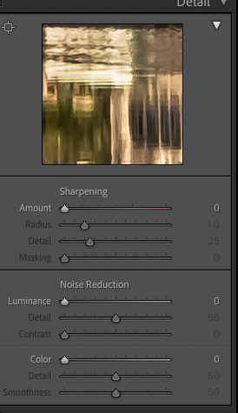
This method starts from Lightroom and assumes Adobe CC. but ignore this step if in Photoshop.

- Do basic Lightroom adjustments to taste but lower Global Sharpening from 40 to 0.

Take image into Photoshop

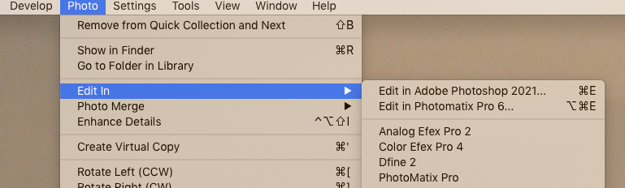

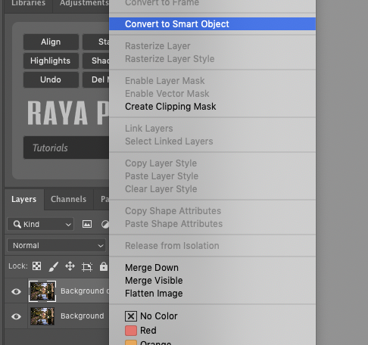
- In Photoshop Make a copy layer of the background and then Right Click on the layer and select “Convert to Smart Object”.

Smart Objects allow you to make non-destructive adjustments to layers which act as an overlay and do not affect the pixels. Mainly works with filters.

For more on Smart Objects go here:-

https://helpx.adobe.com/uk/photoshop/using/create-smart-objects.html

It takes a few seconds to create a smart object but watch for the smart object square appearing in the bottom of the layer Thumbnail image.

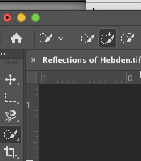
- Next with that layer selected, you want to make a selection of the area to be ‘sharpened’ by making a “Quick Selection”. Choose the Quick selection tool and make sure brush key set to ‘+’

Hone the selection using the +/- brush keys until you have an accurate selection of marching ants. As shown in with the arrows in this arbitrary selection.

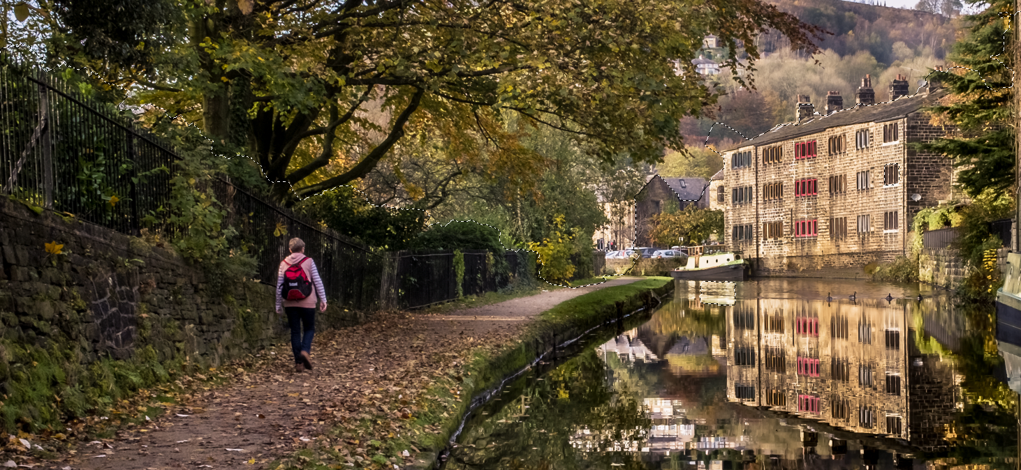

- Once selected go to the Filters Menu and select Other then High Pass

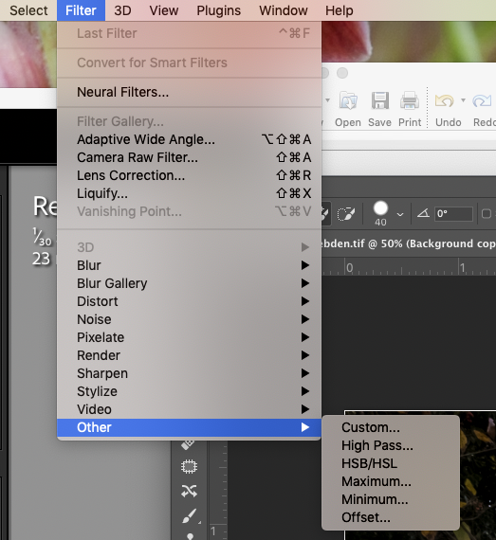

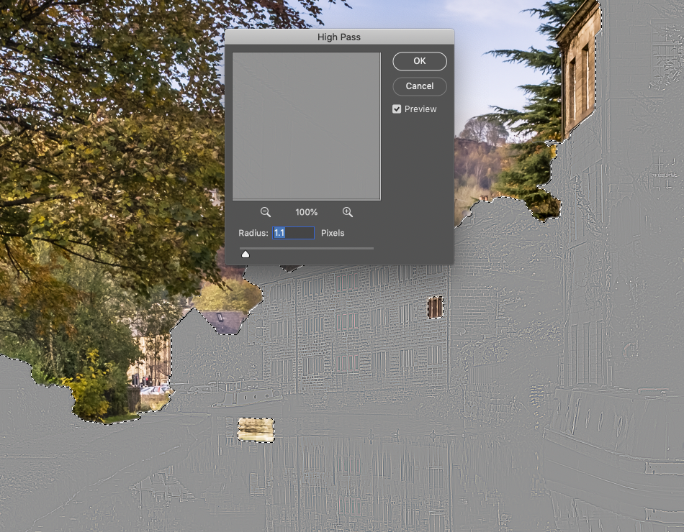
If you find you have missed windows of selection go back.

A Grey mask has appeared over the selection area and a control window. Adjust the Radius slider until the shapes of the required areas to be sharpened are just visible. Don’t overdo this edges need to be barely visible usually between radius of 1 – 2 pixels and rarely 2.5.
When happy click OK and Don’t Panic ! The Grey Mask remains in place!

- Now go to the layer panel and double click the Layer Overlay Blending Adjustment icon on the High Pass Filter.

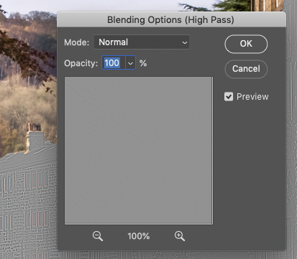
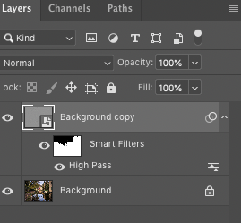
Once you have done this another Control box appears to allow you to apply a Blending Mode
To begin with change the blending mode from Normal to OVERLAY. Once you have selected this your image re-appears with the Blending Mode applied.

- However, you might find OVERLAY to be too strong an application
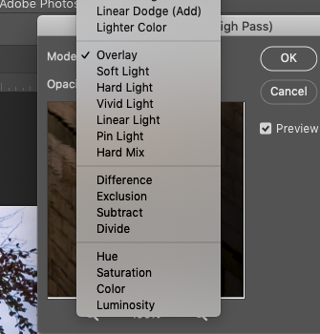
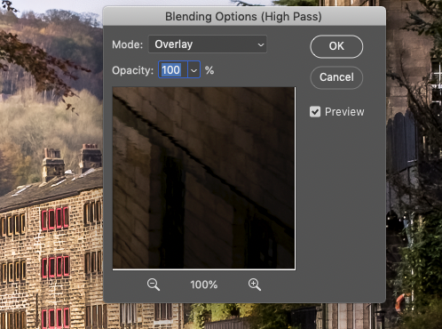

Try Soft Light or Pin Light and it will make the effect more subtle.

For me Overlay tends to make the selection pop out and stand up like inserts in a pop up book so I tend to use Soft Light.

And THAT’S IT!

- Once you are happy you can FLATTEN the image ( Layers Flatten) and save is back to Lightroom or wherever.

OR You can now go onto the next stage of creating a new Layer and Smart Object to repeat steps 1-3 of the above but selecting the sky and then Applying a Gaussian Blur of 1% or so just to soften complicated skies. Filter >Blur>Gaussian Blur

You may then want to go further in Photoshop and apply other layers of sharpening if you wish to selective small areas of detail using Smart Sharpen. This can be applied in several layers if you wish. This is called layered Sharpening

OR Back in lightroom apply selective sharpening using the Adjustment brush set for Sharpening.

