OU / RPS Photography Course MODULE 3
by Stephen Peake and Richard Hearne
Introduction
Welcome to Session 3.
A better understanding of exposure will dramatically improve your photography. Most of the time, we leave our cameras set to ‘automatic’. Even very basic digital cameras are generally very good at measuring the light in a scene and then automatically making a series of decisions about what do with the camera controls to achieve the best result. Simply ‘point and shoot’ in the right direction at the preferred angle, and everything else is done by the camera’s computer. This is often the most practical method and can produce fantastic results. It’s never been easier to take good images.
As you develop your eye, you will sometimes want to override the automatic mode and drive your camera either semi-automatically or fully manually. It could be a snowy scene, a bright beach scene, a fast-moving car, an arty fountain shot, a copy of a whiteboard brainstorm or a document. In each case you will need to know how the camera’s different controls and settings interact to affect the image exposure.
Getting exposure right is both a science and an art. As a science, it is about matching the properties of light in a scene with the characteristics of the camera’s sensor. As an art, it is about knowing how and when to make certain decisions involving different tools and techniques to create images that have impact.
Before you do the activities in this session make sure that you have checked and adjusted your screen. You might like to read the page on adjusting your monitor
[
Tip: hold ⌘ and click a link to open it in a new tab. (Hide tip)
]
. If your screen is not correctly adjusted then you may get very different results (and answers) compared with those given in the comments to the activities. If you consistently disagree then you may need to adjust your monitor.
Next: Learning outcomes

Learning outcomes
By the end of this session you should:
- be able to identify images that are clearly underexposed or overexposed and therefore have a much better idea of near-correct exposure
- understand how to control exposure using camera controls
- understand the limitations of your digital camera to automatically compute the best exposure and how to use it manually to achieve the results you want
- understand how to explore and improve image exposure ‘post-shutter’ in the digital darkroom, using histograms
- understand about using preset controls on images.
Next: Week 3 Study guide

1 How to visually assess the exposure in an image
In photography the term ‘exposure’ has a number of different meanings. Technically, it refers to the amount of light energy received by the camera’s sensor. We’ll explore this shortly as we examine the ingredients of exposure. However, the term is also used to describe a visual quality of an image – for example photographers might say ‘the image is nicely exposed’, ‘it looks very underexposed’, or ‘the swan is a little overexposed perhaps’.
There are three distinct situations where you need to be able to visually assess an image and decide if the exposure is correct or not. In each case, there are different tools available to help you:
- Viewing your own and other people’s printed or projected images – in this situation you must use your eyes to look carefully at the image for clues and tell-tale signs to make an assessment of the exposure.
- With your camera in hand – in this situation you have the camera’s auto settings to guide you, you have the camera’s LCD to view an image and some of its properties, and you also have the camera controls to experiment with and make adjustments.
- In the digital darkroom – in this situation you can view the image properties using the powerful histogram tool, for example, and make detailed adjustments to fine-tune an image to your liking.
The correct exposure for a digital image is the amount of light that produces the optimum balance of tones and colours that you want to convey with your image. Exposure is probably near correct when a further increase or decrease in it produces an image which is less pleasing to your eye. I say probably because ‘correct exposure’ is subjective: there is a degree of artistic interpretation. Frequently people differ markedly in their preference for a version of an image from a set of different exposures.
You will learn more about a computational technique to help you assess exposure towards the end of this session.
Since correct exposure can be a matter of interpretation we are going to concentrate on clear examples of incorrect exposure: underexposure and overexposure.
If you haven’t already done so, you will no doubt take photographs where the principal subject areas are not recorded to your satisfaction; it happens to all photographers. If the camera’s settings result in too little light entering the camera and hitting the sensor then the image appears darker and is said to be underexposed (on the left in Figure 1.1). If too much light is allowed to enter the camera, the image is lighter and is said to be overexposed (on the right in Figure 1.1).
https://learn2.open.ac.uk/mod/oucontent/view.php?id=833617&extra=thumbnail_idp438543664
View larger image

Figure 1.1 Underexposed, correctly exposed and overexposed versions of the same scene
When just the right amount of light is allowed to enter the camera the image is said to be correctly exposed (middle picture in Figure 1.1). The overexposed image appears overall visually brighter, paler and possibly hazy. The underexposed image is definitely darker overall compared with the other two images.
Apart from images that instantly appear too dark or too bright, you can assess an image for obvious under- or overexposure by looking for tell-tale signs in the details in the darker or lighter parts of the image.
Most scenes contain a range of brightness, from dark shadows to light highlights. Underexposure can be identified by a loss of details in the shadows (the darkest tones) and overexposure by a loss of detail in the highlights (the lightest tones).
Let’s look at an example of what to look for in an image that is overexposed.
Look at these two exposures of King’s College, Cambridge taken one after the other using two different scene settings on a camera phone.
https://learn2.open.ac.uk/mod/oucontent/view.php?id=833617&extra=thumbnail_idp438552448
View larger image

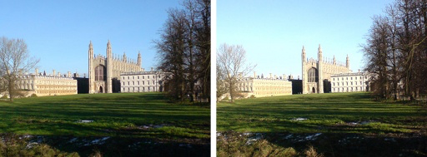
Figure 1.2 King’s College, Cambridge: Image (a) (left) and Image (b) (right)
Activity 1.1
In Figure 1.2, which do you think is the better exposure?
(a)
(b)
So when assessing an image, watch out for lack of colour, overall brightness and lack of detail in lighter areas – these are all signs of overexposure.
Let’s look at an example of underexposure and what to look for.
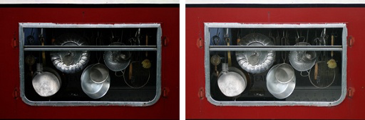
Figure 1.3 Image (a) (left) and Image (b) (right)
Activity 1.2
In Figure 1.3, which do you think is the better exposure?
(a)
(b)
The sign of clear underexposure in an image is lack of details in the shadow areas.
To summarise:
- The clue to assessing whether or not you think an image is overexposed is to look at the details in the highlights and decide whether you feel these should have come out darker. A clearly overexposed image is one that has failed to record details in the brighter areas of the image (the highlights). Sometimes photographers refer to overexposure as ‘burnt out’ or ‘clipped in the highlights’.
- The clue to assessing whether or not you think an image is underexposed is to look at the shadow areas of the image and decide whether you feel these should have come out brighter. A clearly underexposed image is one that has failed to record details in the darker areas (the shadows) of an image. Sometimes photographers refer to underexposure as ‘clipped in the shadows’.
- A correctly exposed image has a range of brightness that reflects the light incident on the scene and the tonal nature of the subject.

When looking at images, ask yourself whether there should be highlights or shadows, given the subject and lighting conditions. Are there highlights or shadows missing, or there when they should not be?
Visually assessing exposure is always easier if you have more than one exposure of the scene to look at. When you can look at a single exposure of an image and form an opinion about the exposure, you are definitely starting to think photographically. ‘Looking’ at exposure is a skill which you will develop over the next few weeks.
Later in the session we’ll see that a great many mistakes can be sorted out in the digital darkroom – but by no means all. The beauty of digital photography is that if you are out and about you can take some images and view them to get instant feedback and then, if necessary, change the exposure to get better results. This is why it is important that you develop your ability to look at or ‘read’ exposure. Now put your skills at reading exposure into practice.

Activity 1.3
Identifying under- and overexposure
Label each of the following images as either underexposed, overexposed or correctly exposed.
Question 1
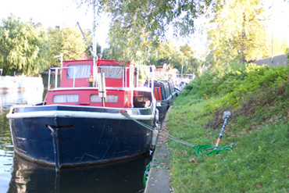
Figure 1.4
Underexposed
Overexposed
Correctly exposed

Question 2
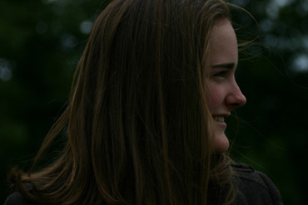
Figure 1.5
Underexposed
Overexposed
Correctly exposed

Question 3
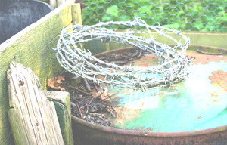
Figure 1.6
Underexposed
Overexposed
Correctly exposed

Question 4
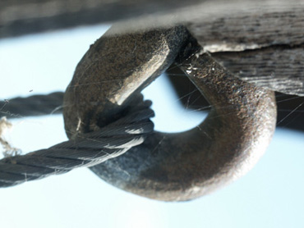
Figure 1.7
Underexposed
Overexposed
Correctly exposed

Question 5
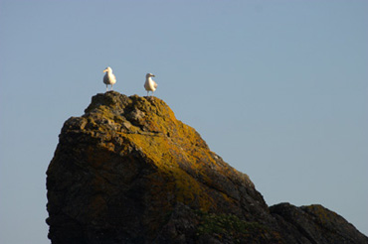
Figure 1.8
Underexposed
Overexposed
Correctly exposed

Question 6
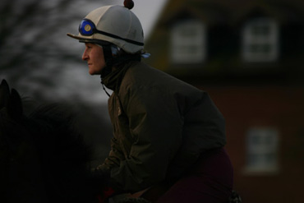
Figure 1.9
Underexposed
Overexposed
Correctly exposed

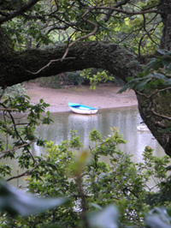

Scenes vary enormously in their brightness range. Brighter subjects reflect more light than darker subjects. A scene can contain a range of brightness from almost black to brilliant white. Every scene is different and of course depends on what it is made up of. The outdoor scene in Figure 1.10 has a wide range of brightness, from dark shadows to very bright areas such as the light bouncing off the boat. The puppy in Figure 1.11 is a largely dark image, while the leaf in Figure 1.12 is overall very bright with few dark pixels. All three images are correctly exposed.

Figure 1.10

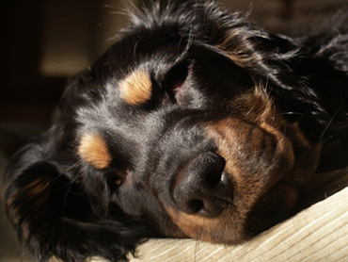

Figure 1.11

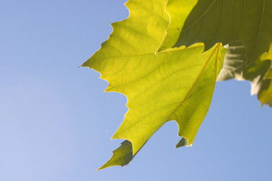

Figure 1.12

The light reflected from a scene has an intensity and colour, which is determined by the light incident on it as well as the type, form and orientation of each bit of the scene.
The ratio of lightness to darkness in a scene is called the contrast. The dog and the boat scenes are high-contrast scenes. In comparison, the leaf scene is a low-contrast scene as the range of brightness is not huge. The contrast in a scene depends on the range of tones – not the average tone. So you can have both dark and bright scenes with low contrast.
The range of contrast that our cameras can capture is actually quite limited. In many situations the photographer has to decide which bits of the image to keep and which to lose in the shadows or in the bright highlights. We’ll return to the theme of what to do in situations of high contrast after we have examined the key ingredients of exposure and the control you have over these as a photographer.
For now you should feel confident that you can identify grossly over- or underexposed images and distinguish them from ones that you feel are probably reasonably ‘correct’.

2 Controlling image exposure before you take the image (pre-shutter)
As you have seen, the term exposure refers to the amount of light energy received by the camera’s sensor. The amount of light is determined by two things: the illumination entering the camera; and the length of time the shutter is left open (shutter speed). The illumination is the rate at which light energy streams into the camera. It is dependent on two factors: the light intensity streaming in; and the size of the camera’s aperture.
An additional factor that affects exposure is the sensitivity or ISO of the sensor, which can be varied. The sensitivity of the sensor is a measure of the speed at which it reacts to light.
There are therefore four ways to control exposure:
- Light intensity – varying the intensity of light reflected from the scene – for example by choosing a bright day or moment, or using a flash or other source of artificial lighting.
- Aperture – varying the amount of light reaching the sensor (for a given intensity – i.e. varying the illumination) by varying the aperture of the lens.
- Shutter speed – varying the length of time the sensor is exposed to the light by setting the shutter speed.
- ISO – varying the sensitivity of the camera’s sensor by setting the sensor’s ‘ISO equivalency rating’.
Exposure depends on all four of these ingredients in such a way that a change in one can be traded for a change in another to achieve the same exposure – but with slightly different photographic effects. For example, larger apertures can throw things out of focus (smaller ones can make everything in focus from near to far); slower shutter speeds can capture movement (faster ones can freeze it). We’ll explore these trade-offs over the course of this and the next session.
Different combinations of these four factors can give the correct exposure. The more intense the light, the smaller the aperture, the faster the shutter speed and the less sensitivity are needed. In dim light the correct exposure may require you to open up the aperture or set a slower shutter speed or alter the sensitivity of the camera, or a combination of all three.
Each combination may have different photographic qualities (sharpness, movement, depth of field, graininess) and as a photographer it is important to understand what these are. Getting the ‘best’ correct exposure is about knowing how each ingredient affects the final image and choosing a combination of settings that best captures and communicates your intentions.
So often in photography, the choice is much more limited. This is because either the circumstances you find yourself in (e.g. dull outdoor light) or the decisions you make about how you want the image to look (e.g. sharp clear picture of a moving car) drastically reduce the choices open to you.
After reading this and the next session, you should understand how to balance these ingredients to achieve a pleasing exposure.
When you set your digital camera to automatic mode (you may own a camera that will only operate in this mode), your camera will make several decisions about all of the above controls (and usually several more, such as white balance, exposure metering (we’ll come to this later in the session) and auto focus).
Depending on your point of view and the needs of the situation, automatic can be a positive or a negative thing: it saves you time but also diminishes your control.

2.1 Exposure modes
Most cameras, including mobile phone cameras, have a selection of different exposure modes ranging from fully automatic to fully manual, with semi-automatic modes in between. Figure 2.1 shows the exposure mode settings on one camera.
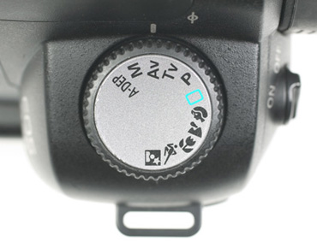
Figure 2.1 Exposure mode settings
Auto or Program – the camera sets the shutter speed and aperture based on the subject brightness using its light meter (more about the camera’s light meter towards the end of this session). These programs are useful and quick to use, but they may not produce the image you want. This mode does produce good pictures if you are in a rush and if the subject matter is fairly static.
Aperture priority – the desired aperture is set by the user and the camera selects the shutter speed to suit the subject brightness. A larger aperture has a shallower depth of field and vice versa (this is discussed in Session 4). This mode is good for setting your depth of field, but watch out you don’t end up with a shutter speed that is too slow.
Shutter priority – the desired shutter speed is set by the user and the camera selects the aperture to suit the subject brightness. Fast shutter speed can freeze movement and a slow speed can show movement. Setting the speed first for the light conditions means you can plan for the image you need and the depth of field follows. This is a good setting for hand-held photography, and gives you time to refine your settings after the first image is taken.
Manual – the shutter speed and the aperture are selected by the user. This setting unlocks you from the camera’s light meter, although there is usually an exposure indicator to suggest the correct exposure.
Exposure compensation – this is not a mode in the same sense as the others, but allows you some partial control to override the camera’s computed exposure if you wish.
The light meter in your camera is not infallible. In certain situations the computer in your camera will calculate an exposure that does not suit the subject, for example bright snow scenes (it has no way of knowing that it is looking at light from snow). To allow for these conditions manufacturers have added an exposure compensation device to many digital camera models. The exposure compensation settings allow the photographer to modify the exposure set by the metering system to increase or decrease exposure.
Next we’ll look in turn at each of the four ingredients listed at the start of this section: light intensity, aperture, shutter speed and ISO.

2.2 Controlling exposure by varying light intensity
How do we control light intensity? For outdoor photography, the answer is mainly to choose the right time. The cost of controlling light can become very significant indeed: dedicated landscape photographers will travel hundreds of miles to be up before dawn or after dark, often at the whim of the weather (and weather forecasts!). They want to catch the light when it is at its most beautiful and avoid ‘contrasty’ scenes in bright daylight which will stretch the sensor’s ability to capture the full tonal range in the scene.
Light can transform the same scene dramatically from season to season, and on windy days that are partially cloudy it can change from minute to minute.
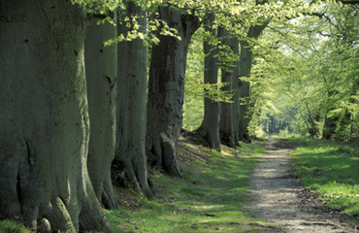
Figure 2.2
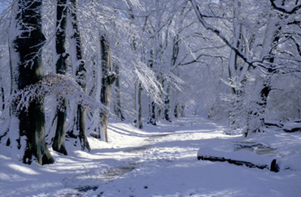
Figure 2.3
At dawn and dusk, the colour and the angle at which light is incident on the scene are often helpful. You saw several examples of the effect of light on a scene in Session 2.
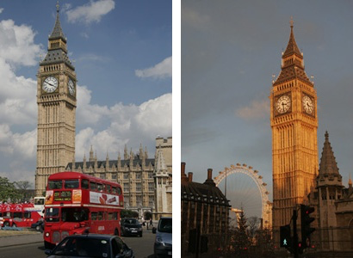
Figure 2.4 The Clock Tower housing Big Ben in daylight and evening light
Lighting effects can also be subtle. It might simply be a case of shifting your viewpoint in a scene or paying attention to the difference in light levels between your main subject and any foreground or background.
If you have a great deal of light, then you may be forced to take images using small apertures. This may have an effect on the depth of field in the image (discussed in detail in Session 4).
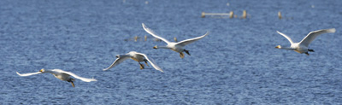
Figure 2.5
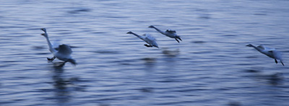
Figure 2.6
In low light you will need longer exposures and so may not be able to catch sharp action of moving subjects (an excellent example is attempting to take photos of Sunday league children’s football on a dull winter day). Or, if your subject is still, you may need to steady your hand or use a tripod to get a sharp image.
Portrait photographers go to a great deal of trouble to control illumination on their subjects. Figure 2.7 was taken with an array of studio lighting.
Figure 2.7
To discuss the control of illumination for different types of photography even at an introductory level would be a whole course in itself. We are going to have to leave this topic here for now.
You probably don’t have access to studio lighting but you do have a flash! Several problems can occur with flash: it can wash out the subject if you are too close and/or give people red eyes (there is a video tutorial in Session 5 demonstrating the red-eye removal tool in Lightroom). If you are too far away from the subject, often flash can have no real effect at all (for example taking an image of a stage performer from a distance).
Flash can also be helpful even in broad daylight. When we use flash in daylight this is called fill-in flash. This is very helpful when taking images of backlit close-up subjects such as this dark cow against a bright sky. The first image is taken without flash and the second with flash, both on automatic.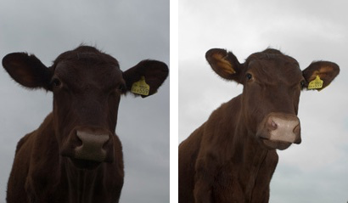
Figure 2.8 Cow taken without flash and with flash
Next we’ll look at the effect of using aperture to control exposure.

2.3 Controlling exposure by varying aperture
The second factor involved in the control of exposure is the aperture of the camera lens. ‘Aperture’ literally means an opening or hole. Cameras can vary the size of this hole by opening or closing a diaphragm in the lens. The diaphragm is made up of a number of intricate metal elements that slide over one another, not quite meeting in the centre.
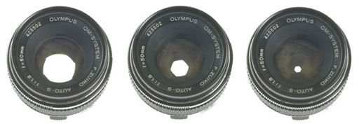
Figure 2.9 Lens with decreasing aperture
The bigger the aperture, the greater the amount of light that enters the camera (for a given shutter speed). Digital cameras provide a range of different apertures to cope with a range of exposure situations.
Aperture size is measured on what is called the f-stop scale. As you progress in your photography and as you look at the work of others, you’ll find that you begin to take more of an interest in aperture, as this can have dramatic effects not only on the exposure of an image but also on its visual qualities such as depth of field (this is discussed in more detail in the next session).
So it is worth feeling confident and familiar with the way aperture size is measured and referred to. Figure 2.10 shows a range of apertures and their associated f-stop numbers. These are written in the form f/X (where X is a whole or decimal number). Study the diagram carefully.
https://learn2.open.ac.uk/mod/oucontent/view.php?id=833617&extra=thumbnail_idp438718384
View larger image

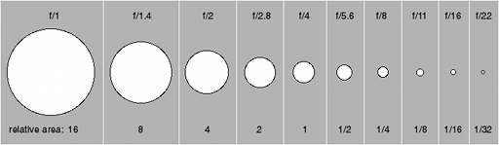
Figure 2.10 f-stop number, aperture and relative area
The first and most obvious thing you may notice is that big apertures have small f-numbers and vice versa. In other words, the area of the lens is inversely proportional to the f-number. We’ll use this later to link aperture with shutter speed.
The system uses the letter ‘f’ because the numbers measure the ratio of the focal length to the effective diameter of the lens, rather than the aperture area directly (we’ll look at this in more detail in Session 4).
You may have noticed that there is no logical progression or obvious pattern to the numbers on the scale. Most aperture values are not whole numbers and the jumps from one value to the next appear irregular. The odd pattern of numbers is a result of the fact that the f-number measures the ratio of focal length to aperture of the lens. So an aperture setting of f/4, for example, is an aperture whose diameter is ¼ of the focal length of the lens (for example a diameter of about 12 mm on a 50 mm lens or 50 mm on a 200 mm lens). Similarly, f/8 is an aperture 1/8th of focal length, f/16 is 1/16th of focal length. Technically in photography we should refer to the aperture setting in full, for example as ‘one quarter’, ‘one eighth’ or ‘one sixteenth’, though most photographers will say ‘f4’, ‘f8’ or ‘f16’.
The specific apertures shown in the figure represent halving or doubling the area and therefore the exposure (all other things being equal). A doubling or halving of exposure is called a stop.

2.4 The stop
The diaphragm in the lens system is designed to control the amount of light entering the camera. The way it does this is by opening and closing – or ‘stopping’ – the light. Hence we say ‘f-stop’.
The stop is a measure of camera exposure. Camera exposure means the amount of light coming into the camera, which is distinct from the lighting conditions or intensity in which the photo is being taken. Changes in ambient light intensity are not measured in stops; this is a subtle but important distinction.
One stop is a doubling (or halving) of the area of the aperture, the shutter speed or the ISO equivalency (these will be described in turn below).
A change in aperture from f/8 to f/5.6 is an increase of one stop, as it doubles the aperture area (see Figure 2.10). Each full stop doubles the area of the aperture and so doubles the exposure (if no other settings are changed). A slowing of shutter speed from 1/60th of a second to 1/30th of a second also gives an increase in exposure of one stop. The same is true of an increase in ISO from 100 to 200 – an increase in exposure of one stop.
Digital cameras often adjust apertures typically by one-third or half-stops. You’ll see below that this is also true for shutter speeds but less so for changes in ISO, which are most frequently changed in full stop increments (more advanced digital cameras can alter ISO by fractions of a stop). When using your camera in semi-automatic or fully manual mode you may need to decide which aperture (f-stop number) to use. You will be confronted with the list so it is useful and important to be able to identify intervals of one stop on the f-stop scale.
It is important to know about the full stop scale – f/1.4, f/2, f/2.8, f/4, f/5.6, f/8, f/11, f/16, f/22 – and to understand that some cameras offer more levels of refinement such as half-stops and third-stops. Figure 2.11 shows the f-stop scale broken into full stops, half-stops and third-stops. This may look complicated but each successive full f-stop increment halves (or doubles depending on which way you read it) the area of the aperture (note that it is only roughly halved or doubled, for a number of technical reasons).
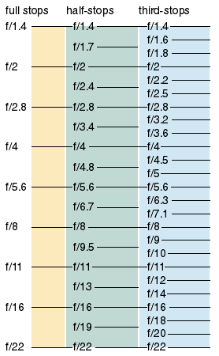
Figure 2.11 f-stop scale showing half and third stops; adapted from figure on p. 72 of George, G. (2006) The Book of Digital Photography, Ilex, ISBN 978-1904705857
Larger apertures are referred to as ‘faster’ than smaller ones as they take less time for the same exposure of the sensor. Hence f/5.6 is three stops faster than f/16.
Before you do the following activities make sure you have checked and adjusted your computer monitor. If your monitor is not adjusted correctly then you may get very different results (and answers) compared with my comments. If you consistently disagree with my comments, for example by a stop, then you may need to adjust your monitor.
Correct exposure is a subtle thing. Within a range, there is no right or wrong answer. It is not uncommon for two people to judge exposure by a difference of a half or full stop. Clearly over- or underexposed images are much easier to identify than nearly correct exposure. So don’t worry too much if you do not immediately agree with my answers – but you shouldn’t be more than a stop out.
Activity 2.1
Your camera: Varying the aperture

How many stops equivalent can you vary the aperture
1
2
3
4
5
6
7
8
9
10
More than 10

We’ll return to the f-stop scale shortly when we look at shutter speed. But first I’d like you to use the interactive camera to explore the effect of aperture value on exposure. In this activity we keep all other controls constant (lighting, shutter speed, ISO) and simply vary the aperture. Which aperture setting do you think gives the correct (best) exposure?
Now test your understanding of aperture by answering these questions.
Activity 2.3
Now test your understanding of aperture by answering these questions.
Question 1
Which is the larger of these two apertures?
f/1.7
f/19

Question 2
Which of the following is one whole stop?
f8 to f16
f1.4 to f2
f9 to f18

Question 3
How many times bigger is the area of an aperture set at f/2 compared to f/8?
4
8
16
32

2.5 Controlling exposure by varying shutter speed
The third ingredient of exposure is shutter speed. Most digital SLR cameras use a mechanical shutter. You hear this as a mechanical sound after fully pressing the shutter button. Simpler cameras may use the camera electronics rather than an actual shutter. In this case the sensor is permanently exposed to light and the shutter action is a timed build-up of a signal.
Shutter speeds are measured in seconds or fractions of a second, typically from around 30 seconds or so to 1/4000 of a second or shorter.
Just as digital cameras are capable of setting a wide range of aperture increments (third- or half-stops), they are also capable of setting a wide range of shutter speed stop increments such as 1/500, 1/400, 1/320, 1/250.
Shutter speeds are indicated on the LCD and/or in the viewfinder of cameras. For speeds faster than a quarter of a second or so the speed is shown as a whole number, so that 1/500th of a second appears as ‘500’ and 1/15th as ‘15’. Slower shutter speeds are abbreviated using single quotes for minutes and double quotes for seconds. Check what system your camera uses for these longer exposures.
A typical readout through a digital camera viewfinder looks like Figure 2.13.
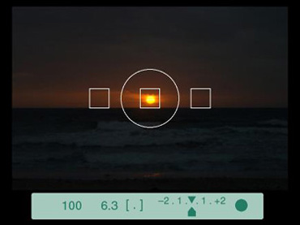
Figure 2.13 Typical digital camera viewfinder readout
The shutter speed is first indicated as ‘100’, followed by the aperture setting f/6.3 labelled as just ‘6.3’, with other information to the right-hand side which we can ignore for now. Examine your own camera and manual to make sure you are familiar with where and how the shutter speed and aperture are indicated on the LCD and the viewfinder, if your camera has one.
As with aperture, a doubling or halving of shutter speed changes exposure by one stop.
Now use the interactive camera to explore what happens to image exposure for a still scene when we vary just the shutter speed (the light intensity, aperture and ISO controls are held constant).

Activity 2.4

Interactive with camera

Which shutter speed gives the best exposure of the model in the studio?
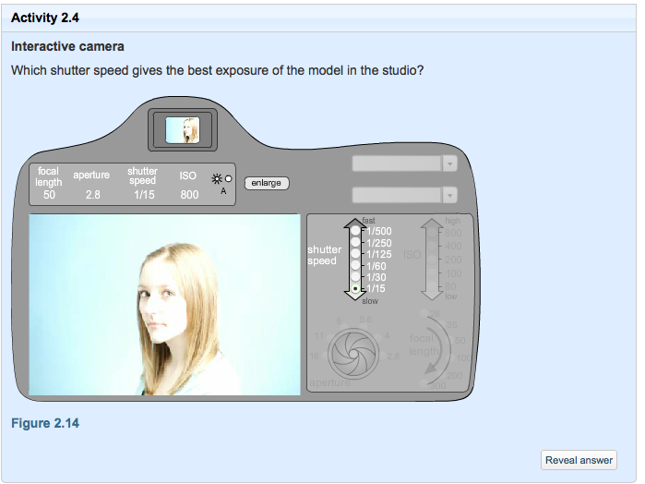
Figure 2.14
Now test your understanding of shutter speed by answering the following questions.

Activity 2.5

Question 1
What shutter speed increases a camera’s exposure setting by one stop from its current position of 1/250th second?

Question 2
How many full exposure stops is the interval 1/125th second to 1/1000th second?

2.6 Movement and shutter speed
Shutter speed can have dramatic effects on the resulting image. The longer the shutter is left open the more the camera records changes in time – any movement either of the camera itself (we call this camera shake) or in the scene (motion blur).
In many instances a good image is one where the subject is ‘pin sharp’. In other situations the photographer may wish to deliberately use movement either in the scene or the camera to creatively capture a moment. Choosing an appropriate shutter speed for your intended purpose in photography is another of those essential technical decisions that are the sign of a good photographer.
Here is a summary of some typical shutter speeds to capture movement or freeze it out for a range of situations, together with some examples of the effects of motion blur for different subjects.
Typical shutter speeds for different situations
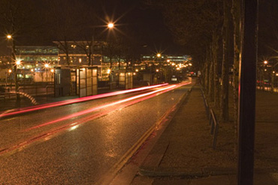
Figure 2.15 Car headlights (8 seconds)
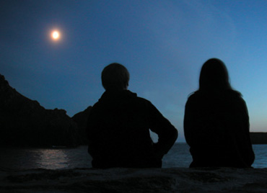
Figure 2.16 Moonlight at the harbour (2 seconds)
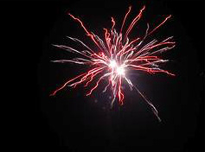
Figure 2.17 Fireworks (1 second)
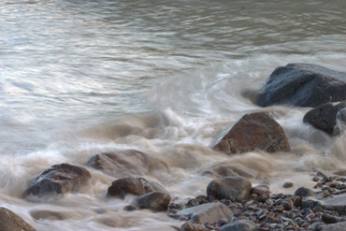
Figure 2.18 Soft waves on a beach (0.3 seconds)
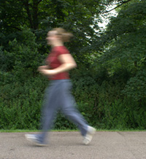
Figure 2.19 Runner in daylight (1/20th second)
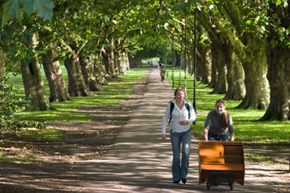
Figure 2.20 Outside shot on a bright day (1/200th second)
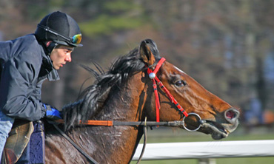
Figure 2.21 Fast sports action (1/320th second)
For some subjects such as traffic, cycling and fountains, motion blur can be a good thing, evoking movement or a sense of time and drama. But for other subjects, such as sports photography, motion blur is definitely to be avoided – the aim is to catch action in sharp focus.
As you see with the fireworks, car lights and beach scenes above, intentional blur can be creative, but try to avoid unintentional blur caused by camera shake: it can ruin an otherwise well seen and composed image. Look carefully at the moonlight image above. The right-hand figure is a bit blurry but the left-hand one and other elements of the image are not. This tells us that the photographer was holding the camera steady and that it was the figure on the right moving which caused the slight blur. This doesn’t detract too much from the image – you might even think it adds something. The tell-tale sign of camera shake is when everything in the image is blurry by the same amount – even things that do not or cannot move! Figure 2.22 is a good example of camera shake Many cameras make a sound or give a visual signal if your image exposure is such that it is causing camera shake. Avoid camera shake unless you want to create this effect intentionally.
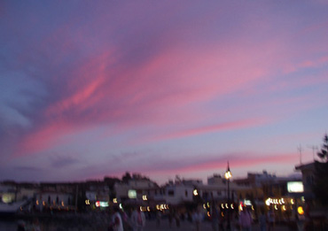
Figure 2.22 Example of camera shake
There are exceptions. A notable one is when you deliberately move the camera to blur a background while trying to keep the subject sharp. This is called panning – you can see this in the racehorse image above. Panning can give an interesting effect and can also help you improve your exposure if you have run out of aperture options to play with.
Slower shutter speeds of 1/30th of a second or longer will record movement in the form of blurring, often caused by movement of the camera as well as the subject. For most situations, faster shutter speeds – typically above 1/250 – will freeze out any camera shake, retaining sharpness in the image. Slower shutter speeds of 1/30th of a second may show camera movement if hand-held unless you hold the camera steady and release the shutter smoothly. Camera shake depends not only on the shutter speed but also the focal length of the lens. We’ll return to this issue in the next session.
Using your camera hand-held (with a short focal length lens) with a setting of 1/125th of a second can capture a scene without showing any blurring of the subject for stationary subject matter. Faster speeds of 1/250th to 1/500th and upwards will ‘freeze’ movement, retaining clarity in the image, typically seen in sports photography.
For longer exposures of a still scene it is necessary to keep the camera still, for example by resting on a surface or using a tripod.
Motion blur in a scene can produce very creative, atmospheric or dynamic images. You will need a tripod to create images like this Figure 2.23.
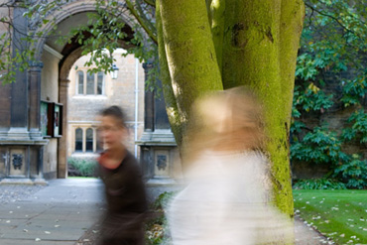
Figure 2.23
Exif data for Figure 2.23
Make | Canon
Model | Canon EOS 300D DIGITAL
Exposure Time | 0.1 sec
ISO Speed Ratings | 200
Aperture Value | F10
Max Aperture Value | F5.6
Focal Length | 80.0 mm
Activity 2.6
Shutter speed on your camera

How many stops can you vary shutter speed on your camera?
- Display possible answers to question
Can't change
1
2
3
4
5
6
7
8
9
10
11
12
13
14
15
16
More than 16

Now use your camera to explore the effect of choice of shutter speed.

Activity 2.7
Interactive with camera
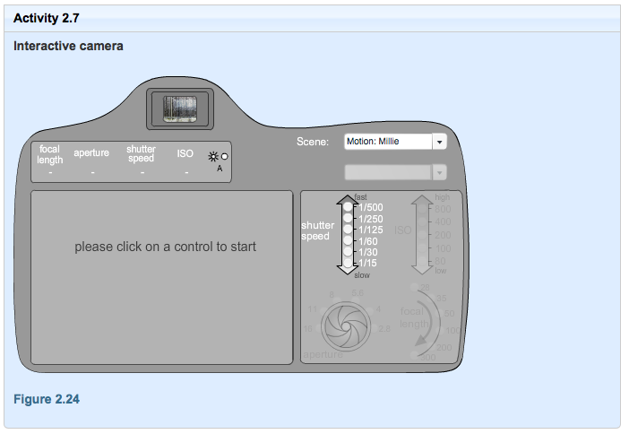
Figure 2.24
Next: 2.7 Controlling exposure by balancing aperture and shutter speed

2.7 Controlling exposure by balancing aperture and shutter speed
Earlier I said that correct exposure can be achieved by different combinations of any of the four ingredients. We have now looked at two of the three camera settings that can be used to control exposure: aperture and shutter speed. Use the interactive camera to explore for yourself how you can balance different combinations of f-number and shutter speed to achieve a good exposure. Find out which combinations give correct or nearly correct exposures.
Activity 2.8
Interactive camera
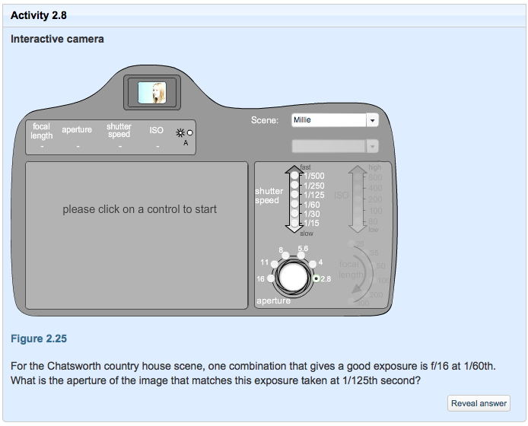
Figure 2.25
For the Chatsworth country house scene, one combination that gives a good exposure is f/16 at 1/60th. What is the aperture of the image that matches this exposure taken at 1/125th second?
Reveal answer
Hopefully you can see that in many situations you have a choice of achieving the same exposure by taking an image with a fast shutter speed and larger aperture setting (smaller f-number), or a slower shutter speed and smaller aperture setting (larger f-number).
Your choices vary with the amount of exposure. The interactive graph in Figure 2.26 is a simplified version of the ‘exposure value’ (EV) table invented in Germany in the 1950s to help photographers obtain the right exposure. Developments in photography mean that today the EV system is quite unfashionable, but I think it is still an extremely useful way of understanding the relationship between aperture and shutter speed. It is included here for interest only, because you do not need to understand the specifics of EVs. In the bottom right of the graph, exposures are extremely fast and with tiny apertures – settings for very bright scenes, for example. In the top left of the graph exposures are extremely slow and at very wide apertures – settings for low light intensities perhaps.
Click on the options in the graph to see the full range of balances that can be achieved between aperture and shutter speed for different levels of exposure. As you move left or right, or up or down, you move by one stop each time. EV 0 is defined as f1 for 1 second at ISO 100 (two stops off the top of this scale). If we held up an incident light meter on a sunny day towards the sun it would read EV 15–16 and we would know that any combination of aperture and shutter speed that lies along EV 15 in the diagram would produce a good exposure. The most important thing to understand from this graph is that all combinations of aperture and shutter speed on the same diagonal allow the same amount of light to enter the camera and are therefore the same exposure value. In other words, if you took the same scene at any of the combinations along the same diagonal, the images would be identically exposed.
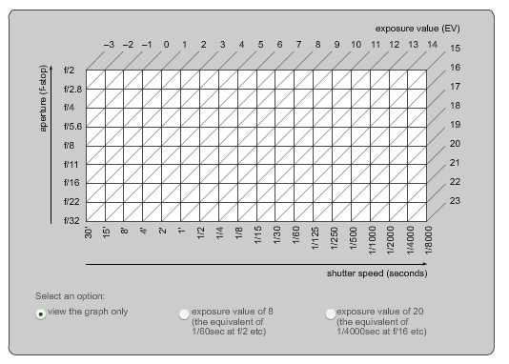
Figure 2.26
Different combinations of shutter speed and aperture give the photographer a choice to represent the subject in different ways: freezing motion with high shutter speeds, showing lyrical blurring movements with slower shutter speeds, or creating images fully or partially in focus.
Activity 2.9
Using the exposure value graph, which of the following are equivalent to an EV of 8?
- A.1/60th at f/2
- B.1/30th at f/2.8
- C.1/8th at f/4
Reveal answer
Next: 2.8 Controlling sensitivity by varying sensor sensitivity (ISO)

2.8 Controlling sensitivity by varying sensor sensitivity (ISO)
The fourth and final ingredient of exposure is the camera sensor’s sensitivity setting (or ISO equivalency).
Changing to a higher ISO setting on your digital camera amplifies the electronic signals received from the camera’s photosensor. All electronic devices that capture and transmit signals (TVs, radios, hi-fis) also transmit a degree of electronic noise along with the signal. The relationship between them is called the signal-to-noise ratio. The camera catches the light signal entering the lens and records this along with a small amount of electronic noise in the image file. Strong signals (intense light conditions) drown out most electronic camera noise (high signal-to-noise ratio). However, in weak lighting conditions (low signal) the electronic noise can be seen in the image (low signal-to-noise ratio).
The most common type of electronic noise you are likely to see in your image is random noise. This is easier to spot in areas of plain colour.
Random noise looks like speckling, as shown in Figure 2.27.
Figure 2.27 Random noise
Digital noise increases as ISO increases. So why bother to increase ISO?
Recall that there are four ingredients of exposure, and correct exposure could be achieved by different combinations of any of the four ingredients. In very low-light intensities you may need more options to vary aperture and/or shutter speed to achieve the effect you want. In such circumstances, if you increase the ISO you create more flexibility in the choice of other settings (aperture and shutter speed) that are available to you to achieve a good exposure.
So there is a trade-off between higher sensitivity (more flexibility) and increased noise.
Typically, ISO ratings go up or down in full stops.
When the ISO rating doubles, this halves the amount of light needed to correctly expose the image. A setting of ISO 200, for example, needs half the light to form an image than a setting of ISO 100. Or put the other way round, every time the ISO setting is halved, the amount of light required for the exposure doubles.
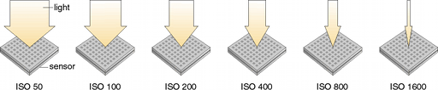

Figure 2.28 ISO settings and amount of light needed
- How many stops are there between ISO settings of 50 and 400? Reveal answer
The great thing about digital photography is that you can change the sensitivity of the camera to suit each picture at the flick of a button. You could be on a day trip to a museum, for example, and one minute taking group shots in bright light and the next attempting a shot of some ancient sculpture in relatively low indoor light without a tripod to keep you steady. It’s in these circumstances that you should remember that increasing ISO may give you more options.
Unfortunately, some digital cameras amplify noise and produce grainy images when set above ISO 200 equivalent. Try and you’ll find out! So try to take images with as low an ISO as possible to minimise the amount of noise in your images, but don’t be afraid to experiment.
There are advantages and disadvantages to using different ISO settings. Here are some general rules.
- ISO 100 can give good picture quality, but is not sensitive enough for hand-held photography in lower light conditions.
- ISO 200 is better for hand-held work in general outdoor lighting, with a slight drop in quality.
- Higher settings such as ISO 800 enable fast shutter speeds to be used, and are good for working with low light levels, but images will show an increase in noise.
Use the interactive camera to explore the effect of ISO together with different combinations of aperture and shutter speed.
Activity 2.10
Interactive camera
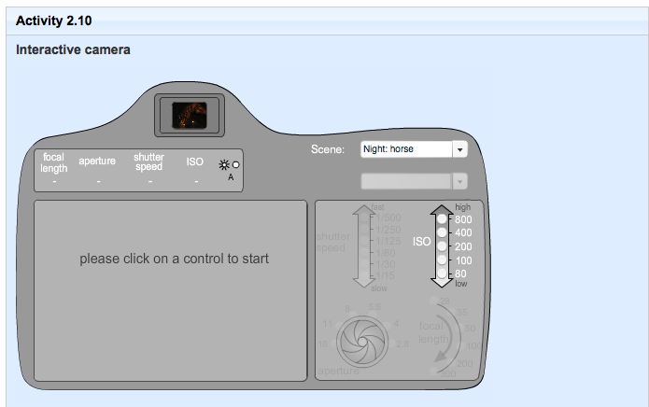
Figure 2.29
There are four low-light scenes, each using a variety of ISO settings:
- In the night-time horse scene the photographer takes a series of shots varying just the ISO – everything else is constant (including lighting). Can you see that increasing ISO increases exposure?
- In the night-time columns scene the photographer is experimenting with taking hand-held shots and avoiding camera shake by using ISO. Can you see that at the lowest setting (ISO 80) we start to see some camera shake as the correct exposure requires 1/5th second – too long for sharp hand-held images. Notice that the exposure of all images is about the same.
- In the night-time actor scene there are just two shots, both hand-held, with a relatively long lens. In the shot taken at ISO 200 the spotlight was on the subject and the photographer was able to take an image at relatively low ISO. While the acting and the spotlight moved across to the other side of the stage the photographer then took the ISO 800 image. The trade-off between shutter speed (camera shake) and noise is very clear.
- In the night-time Kings scene there are again just two shots. The increase in noise at ISO 800 is again clearly visible (both shots were taken using a tripod).
We’ve completed our tour of the ingredients of exposure. So far in this session you have been exposed (the pun is intentional!) to a lot of new information about the balance of camera controls. Now reward yourself and impress your friends with your knowledge by making sure you can correctly answer the following questions.

Activity 2.11
Testing your understanding of exposure
Question 1
You are out at dusk and the light is fading fast. You are operating your camera manually, experimenting. You have composed a shot and the largest aperture setting is f/5.6. You have found that 1/60th is the right exposure but you are worried you may be capturing camera shake. Then you decide to change from ISO 200 to ISO 400. What shutter speed will now give the same exposure?

Question 2
You set your camera on automatic and point it at a scene. It tells you that the ideal exposure is f/8 for 1/500th second. Then you notice your ISO is set to 400 (you forgot to change it from the night before!) and you’ve also remembered that your task today is to take a photograph with the largest aperture you can. So you change the ISO to 200 and put the camera into aperture priority mode and set it at f/2. Can you predict what shutter speed the aperture priority mode will now suggest you take the image at?

Question 3
You often see landscape photographers out and about with tripods. This is because they often take photographs early in the morning or late in the evening and so use very slow shutter speeds. Imagine that a landscape photographer was up a mountain at dawn and accidentally dropped her tripod over the edge of a cliff and couldn’t retrieve it. She has taken a long time to climb the mountain to get that picture and is determined not to go down empty handed. It’s a beautiful morning. How might the photographer compensate for not having a tripod? Could she:
- A.Widen aperture to make shutter speed faster to avoid camera shake at slower shutter speeds?
- B.Make the aperture smaller to make shutter speed slower?
- C.Increase ISO to make shutter speed faster?
- D.Brace herself against a rock or balance the camera on a rock and take a photo?
Question 4
In photography there is something called the ‘sunny 16 rule’, which enables you to choose the correct shutter speed even without a light meter. The rule is that at an aperture of f/16 on a sunny day, the shutter speed will be the closest shutter speed option you have to whatever ISO rating you are using. So if you are using an ISO setting of 100 the shutter speed you would set would be 1/125 (unless your camera has the option of 1/100 as some DSLRs do). If you remember what you have already learnt about doubling and halving you should be able to calculate appropriate shutter speeds for larger or smaller aperture settings.
You are out on a sunny day and want to use an aperture of f/8. You also want to use ISO 100. You remember the sunny 16 rule to help you work out the shutter speed. What shutter speed should you use according to the sunny 16 rule?
- A.1/500th of a second
- B.1/250th of a second
- C.1/60th of a second
- D.1/125th of a second

2.9 Controlling exposure by varying control of light metering
You have now seen how the four ingredients of exposure interact and how different combinations of settings can achieve the same exposure (but with some different photographic effects).
Digital cameras are packed full of clever bits of technology. In many circumstances we can set them to fully or partly automatic and not worry about exposure calculations. One of the cleverest aspects of your digital camera is the light metering system it must have to function automatically.
When your camera is set to automatic, and you press the shutter button to take a picture, in a fraction of a second the camera has measured the amount of light reflected from the scene, done some calculations, made some decisions and then altered up to three of the camera controls (aperture, shutter speed and ISO). And whatever scene you point to, within limits, the camera produces reasonable, and sometimes very impressive, results.
Now we are going to delve a little deeper into the way your camera measures light and what this means for various photographic situations.
Every digital camera has an in-built reflected light exposure meter. To deal with different exposure conditions digital cameras are equipped with different metering modes for the photographer to select. In this sense, metering means that the camera doesn’t treat all areas of the image equally. In controlling exposure, it takes more notice of certain areas in preference to others.
Here are some types of metering you may come across.
Evaluative or matrix metering – the picture area is divided into segments and each point is assessed and the exposure is calculated for the entire image area. The meter measures each segment individually and computes the optimum exposure using exposure evaluation algorithms to give an appropriate exposure. Matrix metering provides excellent metering for most situations.
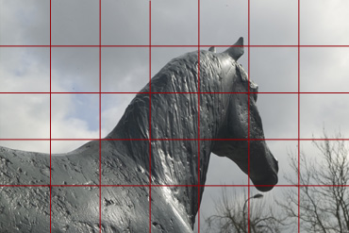
Figure 2.30 Evaluative of matrix metering
Centre-weighted metering – the exposure is calculated from the light over the whole picture area, but precedence is given to the light in the centre.
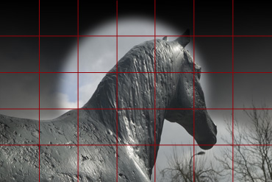
Figure 2.31 Centre-weighted metering
Partial metering – the exposure is taken from a smaller area in the centre of the picture area. This is useful for metering an important area in a scene and is classically used when taking a portrait image with light coming from the back.
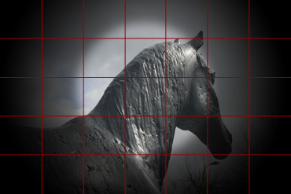
Figure 2.32 Partial metering
Spot metering – the exposure is taken from a small area in the centre of the picture area. This is useful for metering a very small and specific area in a scene – a grey card, for example (we’ll come to this shortly) – to help you determine an exposure very precisely.
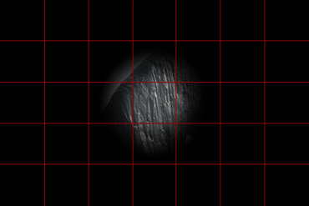
Figure 2.33 Spot metering
Many people using a camera to take holiday snaps point and shoot at a scene with the main subject usually in the middle. Camera manufacturers take this into account when they design new cameras. At one time the default metering mode for many automatic cameras was centre-weighted and this gave good results for typical outdoor scenes. The default mode in today’s digital cameras is more likely to be evaluative or matrix metering.
Partial and spot metering give you the most control over exposure but for that reason are also the most difficult to use. However, these modes come into their own when you want to be very precise about a subject in a scene, in unusual lighting conditions or when you want to explore image exposure more creatively.
Activity 2.12
Your camera's metering options

Does your camera have different metering options?
Yes
No

If you do have different metering modes, experiment with a subject by varying the mode and looking at the results.
Alternatively, use the interactive camera to see an example of the effect of selecting different metering modes on how the camera interprets the correct exposure.

Activity 2.13
Interactive camera
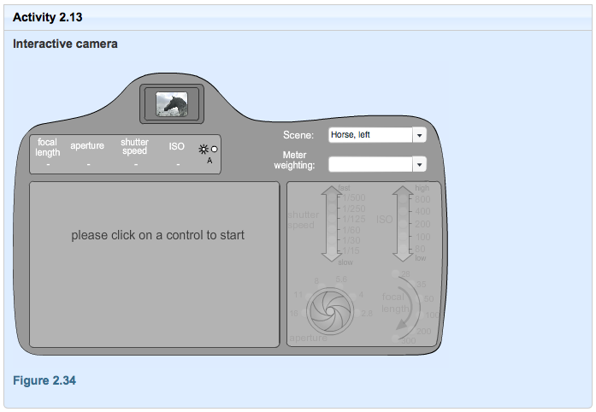
Figure 2.34
As you saw in Session 2, there is a difference between incident light on a scene and reflected light from a scene. Different exposure meters have been developed to read either or both types of light. Each metering type has its advantages and disadvantages. Incident light meters are usually separate devices independent of the camera. They give more accurate exposure readings for the majority of situations and subjects because they are usually unaffected by variations in the reflectance of the subject or scene. Reflected spot metering can be helpful when measuring highly reflective or high-contrast subject matter. The meter shown in Figure 2.35 is an incident light meter (the white ‘lumisphere’).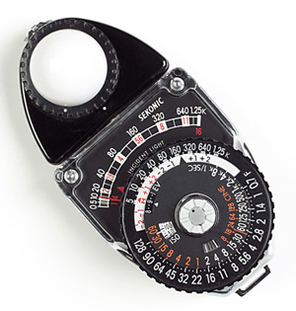
Figure 2.35 An incident light meter
Digital camera meters use the reflected light method measured through the lens or TTL.
Light meters are designed to measure light accurately and consistently. However, they have no way of knowing what they are looking at in the way the photographer can interpret a scene. A reflected light meter cannot distinguish between a black and a white horse, or tell snow from peat soil, or a red umbrella from a blue umbrella.
For the same lighting conditions, a reflected light meter reading from these different subjects would indicate different exposures. An incident light meter would indicate nearly the same exposure every time.
Set to automatic, our cameras ‘read’ the light reflected from a scene and make adjustments to the exposure to allow for the fact that they are measuring reflected and not incident light.
The 18% grey issue
If you study exposure in more detail, in almost every book on the subject you will read that ‘light meters are calibrated to 18% grey’, or words to that effect. There is in fact no international standard for the calibration of TTL reflected light meters. Calibration is the proprietary technology of camera manufacturers and is therefore a source of technical competitive advantage among them.
The 18% grey issue has a complex technical history rooted in the first attempts by Kodak scientists in the early 1940s to find the brightness range for what they called a ‘statistically average scene’ and ongoing research into film speed. The 18% figure emerges almost as a by-product from the history of the standardisation process between reflected and incident light metering. Specifically it emerges as the ratio between the calibration constants for the reflected and incident light metering methods of determining exposure (the figure that actually emerged was 16% – but that’s another story!).
Do not become too distracted by the 18% grey issue. The equivalent figure for your camera may be different – the precise figure may vary from one camera to another as well as over time, as metering technology continues to improve.
A fun and dramatic demonstration of how your camera automatically adjusts for exposure is to take three images: of a white, a grey and a black piece of paper. If you haven’t done or read about this before, you may be quite surprised with the results. In some conditions, you’ll never quite trust your camera in automatic mode ever again!

Activity 2.14
How to take a truly boring photograph
In this activity you are going to take three photographs – one each of three differently toned sheets of A4 paper: white, grey and black.
Set your camera to automatic. If you can, switch off autofocus and focus manually (focus isn’t critical for this experiment, but autofocus doesn’t like taking photos of A4 sheets of paper – or any other scene of solid tone or colour – and if left on it may stop you).
Take a photograph of each of the three pieces of paper in turn. Each time make sure that you fill the frame of the picture with the white, grey or black tones. Don’t have anything creeping in at the edges such as the ground or your shoes!

Unfortunately, then, exposure meters are not infallible. There are times when the meter may misinterpret the reflected light.

Activity 2.15
Testing your understanding of light metering

Question 1
With your camera set on auto can you predict what is likely to happen when you take a predominantly bright scene such as a snow scene or an image of white paper or a whiteboard?
The camera will sense relative amounts of dark and light areas and adjust the exposure correctly.
It’s highly likely the image will be very overexposed.
It’s quite likely the image will be a touch underexposed.

Question 2
With your camera set on auto can you predict which outcome is most likely when you take a predominantly dark scene such as a close-up shot of a black cat waiting patiently in the shade for its owner to return?
There is less light reflected from this scene so the camera can adjust the exposure correctly.
It’s quite likely the image will be a touch overexposed.
It’s quite likely the image will be a touch underexposed.

Underexposure can result where a white background predominates. The meter tells the camera it is very bright and sets a lower exposure, which leaves the average tones underexposed. Overexposure can happen when dark tones predominate. This time the meter thinks there is not enough light and sets a higher exposure, which overexposes the average tones.
As we saw earlier, to allow for these conditions manufacturers have added an exposure compensation device to many digital camera models. The exposure compensation button allows you to override the auto exposure settings and add more or less exposure. We’ll return to exposure compensation later in this session once I have reviewed the other aspects of exposure.

3 Exploring and controlling exposure in the digital darkroom: the histogram
The histogram is an extremely useful tool to help you to examine image exposure and make decisions about making any modifications to an image post-shutter – in the digital darkroom.
A histogram is another name for a graph which shows the frequency, usually on the vertical (or Y) axis against a variable quantity, on the horizontal (or X) axis. A histogram is sometimes referred to in mathematics as a ‘frequency distribution’. Histograms are used in digital photography to explore the frequency of tones (from dark to light) and/or colours in an image.
Photoshop Lightroom (and in some cases the software carried on-board more advanced digital cameras) can read the digital (binary) data in an image file and build a graph of the relative brightness level of each pixel. It then plots the result as a histogram of the relative lightness/darkness of pixels in the image. Looking at the histogram of an image gives us another way to assess the range of brightness in an image and therefore whether or not we think the image is correctly exposed.
Histograms are not specific to photography – these sorts of graphs can be used to investigate lots of situations. For example, we could build a histogram of how long TG089 students have owned their digital cameras.

Activity 3.1
Your camera
Most digital cameras (except for very expensive ones) produce images with a maximum range of brightness of 256 levels.
To understand how software builds the histogram, imagine that a colour image is taken and first transformed into black and white. Then the software analyses the image pixel by pixel. The image comprises several hundred thousand tiny squares of uniform tone (in the case of a 1024 × 768 pixel image it would be 786,432). The software then sorts these pixels into piles according to the brightness of each one – with the darkest labelled level 0 and the brightest labelled level 255. The number of pixels in each pile gives you the height of the bars in the histogram.
In Lightroom, very bright areas of an image are called highlights. Very dark areas of an image are called shadows. Areas of brightness that lie in the middle are called mid-tones. You will soon see that these terms are not only very helpful in describing the properties of different parts of a scene, but they are also related to some key tools in the digital darkroom.
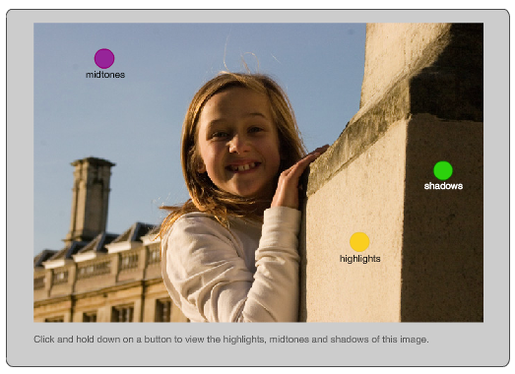
Figure 3.1
Let’s look again at three of the images we saw earlier, but this time with their histograms as they appear when you view the images in Lightroom.
But first a friendly warning!

There is no ‘correct’ shape for a histogram. It all depends on the type of scene you are taking, the light and other factors you wish to control. Scenes vary enormously in their brightness ranges. Ultimately, it is the image itself that should dictate whether or not you think you have managed the exposure correctly. The histogram provides useful information about the image, but there may be a conflict between what the histogram shows and what your eyes tell you is pleasing about exposure.
Figure 3.2 shows the image of the puppy and its histogram. The histogram shows that the majority of the pixels are in the shadows area (the left-hand third of the histogram), but there are a few pixels in the mid-tones and in the highlights. The histogram shows that the camera has done a good job of capturing the full range of brightness. The image is correctly exposed, as there are pixels all the way up to the brightest (there are just not that many of them). This is an example of an image with a tonal range in the shadows.
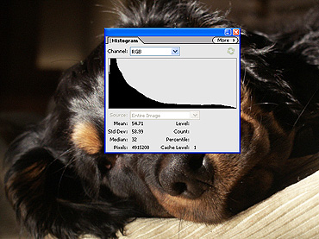
Figure 3.2
The histogram of the leaf image in Figure 3.3 shows that most pixels are in the region of midtones up to highlights, but again there are some dark pixels in the image all the way down to level zero. If you look carefully you will see that there are no pixels in the highest levels. This is a sign of slight underexposure. The tonal range of this image is in the upper midtones to highlights.

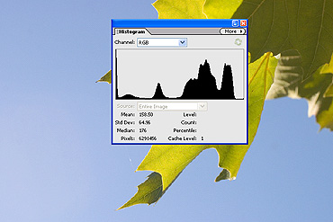
Figure 3.3

The outdoor scene in Figure 3.4 is a fairly ‘normal’ scene (a touch on the dark side), meaning that it has a range of tones from dark to light. A correctly exposed ‘normal’ scene shows a full range of tones from very light to very dark.
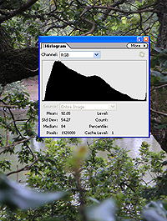
Figure 3.4
You have seen that you can see histograms using a photo editing software, and your camera may offer a similar feature.

Activity 3.2
Your camera
In general, you should choose the exposure so that tonal range in the image matches the brightness range in the scene as best it can.
For low-contrast images this is usually possible (though you may need a tripod in low light and you may have to compromise on image quality by moving to higher ISO).
For high-contrast scenes, frequently the sensor’s 256 levels of tone cannot match the huge range of brightness in the scene. This is especially true in strong natural or artificial lighting.
For high contrast scenes, we must make a choice between keeping the details in the highlights but losing the details in the shadows (because the range is too great for the sensor) or keeping the details in the shadows but losing the details in the highlights.
In extreme contrast situations, it is the convention that photographers opt to keep the details in the highlights.
Figures 3.5 and 3.6 show an example of the problem of exposure when shooting into the light on a sunny day. You can see from the reflection of light on the sea that this view of the Lizard Peninsula is more or less taken toward the sun. Both histograms show exposure across almost the full 256 tonal range. In the image in Figure 3.5, the exposure was taken to reveal detail in the highlights (the cloud, sky and reflections on the sea). The rock in the foreground shows little detail. In the image in Figure 3.6, the exposure was taken to show detail in the shadows (the rock foreground) but consequently the details in the highlights have been completely burnt out.
Both images are in one sense not so badly exposed: the camera is capturing what the controls allow. These two images are weak pictures because they are badly seen: the camera and photographer had little hope of capturing this stunning scene as the eyes saw it after a stiff climb up the coastal path. The moral of the story is that when it comes to high-contrast scenes you should not confuse poor exposure with poor photography!
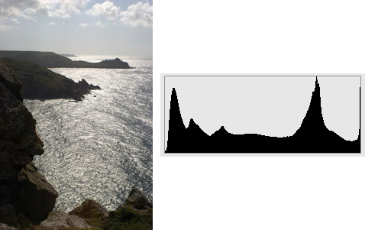
Figure 3.5 Lizard Peninsula and histogram showing detail in the highlights but little detail in the shadows
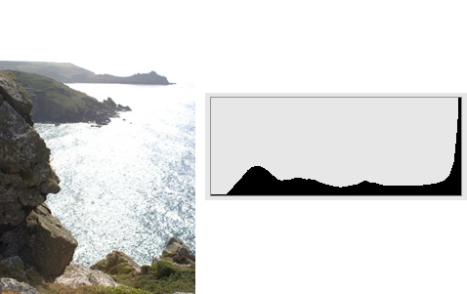
Figure 3.6 Lizard Peninsula and histogram showing detail in the shadows but little detail in the highlights
There are various ways around the problem of high-contrast scenes. One way is to create so-called high dynamic range (HDR) images, and there is something of a fashion for this in photography at present. To create an HDR image, you take different exposures for different parts of the scene (using different camera exposure settings) and then stitch the best bits together in the digital darkroom. To do this you need to keep the camera absolutely still between takes, which is difficult. The video tutorials in Session 8 show you a way to do this when you only have one badly exposed image to rescue.
Figure 3.7 shows one more example of an overexposed scene which neither the camera nor the photographer had much chance of controlling because of the poorly chosen view point. Again it is shot into the light – this time the sun isn’t out but there is a very bright overcast sky, one of the trickiest outdoor lighting conditions of all. You can see the image is burnt out at the expense of the detail in the horses and riders.
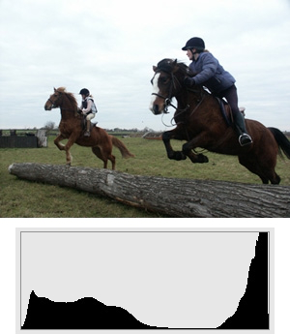
Figure 3.7 Example of an overexposed image and its histogram
Again, some detail in the horses and riders could be rescued in the digital darkroom.
If you are not sure about the correct exposure you can always take several slightly different exposures half or one stop over and under what you think the optimum will be. This is called exposure bracketing. However, this isn’t an option with sports action photography such as this!
Now watch the video tutorials on using the histogram to manipulate image exposure in the digital darkroom. You will learn how to manipulate exposure of the image at the top of Figure 3.8 to create the image at the bottom, and how to convert an image to black and white.
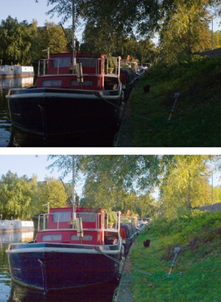
Figure 3.8 Original image and version with improved exposure
Histogram – Part 1 (7 minutes)

Activity 3.3
In the previous video tutorial (Histogram – Part 1), what information is shown just below the histogram?

4 Assignment for Week 3

Activity 4.1 Exposure safari
Spend up to four hours on the assignment.

Capture two well-exposed images from at least two of the following categories of varied and challenging lighting conditions:
- Creative motion blur in low or normal light conditions (e.g. walking, cycling, cars, sugar falling from a spoon, running water, car lights after dark). For this task you will need to steady your camera by either resting it on something or using a tripod. Avoid camera shake.
- Low-light, high-speed (high ISO) still photography (e.g. moonlight, street lights). This can be hand-held if the shutter speed is fast enough or using a tripod or other camera support as appropriate. Avoid camera shake.
- High-contrast photography (bright indoor lights, or bright daylight, or highly reflective subjects).
Do
Converted it to black and white.

Do
When you have finished your photo shoot you can import your images into Lightroom. You may also wish to edit them in Lightroom.

